PSSI Science Project Reporting Template

️ | The PSSI Implementation Team is compiling a technical report to demonstrate the important research and advancements made by the Science Branch through the PSSI funding. The technical report will include a 3-4 page summary (including graphics and figures) for each project to show their key results and findings. Please fill in the following fields and sections for your project to be included in the report. Feel free to include and draw from any reports or presentations previously created through your research.  A plain language science bulletin will also be created to follow up on last year’s “DFO Pacific Region Science Bulletin, 2024. New research and monitoring for Pacific salmon and their ecosystems.” While the first bulletin introduced project backgrounds, methods, and timelines, this new bulletin will highlight the projects’ results, key findings, and conclusions with links to reports and data available. The bulletin will include a 1-2 page summary for each project gleaned from the content entered below.  ️ Completed forms are due January 7, 2026.  *Please include or send separately any graphics or pictures (with photo credits) that will help promote the projects.

PART 1: PROJECT METADATA

General Project Information
Project ID (number) | Project Title
2425 | Geospatial Indicators and Metrics for Threats to Fish Habitat in the Fraser River Basin with Thompson-Nicola as a Case Study
Project Leads | Collaborations and External Partners
Josephine Iacarella, Keegan Paterson, Daniel Weller
Location (if applicable)
Fraser River Basin

Geographic and Stock Information
Salmon species (if applicable) | Waterbodies (if applicable)
Coho, Chinook, Sockeye, Pink, Chum | Fraser River
Life history phases (if applicable) | Region
All freshwater phases | Fraser
Stock (if applicable) | Population (if applicable)
Click or tap here to enter text. | Click or tap here to enter text.
Conservation Unit (if applicable)
CK-03, CK-04, CK-05, CK-06, CK-07, CK-08, CK-09, CK-10, CK-11, CK-12, CK-14, CK-16, CK-17, CK-18, CK-19, CO-05, CO-07, CO-08, CO-09, CO-48, SEL-03-02, SEL-03-03, SEL-03-04, SEL-04-01, SEL-05-02, SEL-06-07, SEL-06-10, SEL-06-11, SEL-06-13, SEL-06-14, SEL-06-16, SEL-07-01, SEL-09-xx, SEL-10-01, SEL-10-03, SER-02, CK-13, CK-15, CK-82, CM-02, CO-04, CO-47, PKE-9005, PKO-01, SEL-03-01, SEL-03-05, SEL-06-01, SEL-06-02,
SEL-06-20, SEL-09-02, SEL-09-03, SER-03

🧰 PART 2: PROJECT METRICS

Project Outputs
Include any anticipated outputs denoted as (in progress). Please include links to any outputs available online so they can be referenced in the report.
List scientific publications and technical reports (with links)
Iacarella, J.C., Paterson, K., Potapova, A., & Weller, J.D. 2025. Geospatial indicators and metrics for threats to fish habitat in the Fraser River Basin with Thompson-Nicola as a case study. DFO Can. Sci. Advis. Sec. Res. Doc. 2025/013. xiii + 126 p. Geospatial Indicators and Metrics for Threats to Fish Habitat in the Fraser River Basin with Thompson-Nicola as a Case Study
List datasets generated (with links)
freshwater-spatial-ecology/Cumulative-Threats-FRB-2024
Describe dataset locations and data management systems
GitHub
List code, programs, or other software created (with links)
Code shared as needed upon request.
List communication or social media products
Click or tap here to enter text.
List and describe field work completed
Click or tap here to enter text.
List and describe samples collected/analyzed (number of samples)
Click or tap here to enter text.
List and describe large capital assets or equipment acquired
Click or tap here to enter text.

PART 3: WRITTEN CONTENT

Highlights
Please summarize in 2-3 bullets:
- The main idea of the project
- Key findings
- Implications of these findings for salmon and decision-makers
- For a more technical audience, but still as plain language as possible
- Human activities, landscape disturbances, and climate change are presenting numerous individual and cumulative threats to fish and their freshwater habitat across British Columbia (BC). Modern tools and approaches for tracking and assessing these threats are needed to support responsive and integrated regulatory, planning, partnership, and monitoring activities to help safeguard fish and fish habitat.
- We developed geospatial estimates of individual and cumulative threats to salmon and Species At Risk habitat in the Fraser River Basin from human activities, landscape disturbance, and climate change (e.g. pollutant loading, sedimentation, flow alteration, high stream temperatures). We modelled and mapped 13 threats for the full stream network and identified where and for which species threats were higher. We further applied the threat scores and indicators of important habitat for salmon in the Thompson-Nicola to help inform restoration planning for salmon ecosystems.
- This project is the first to provide spatially extensive estimates of freshwater threats to salmon and inform how restoration and management actions can potentially improve population outcomes. The estimated threats are now used in salmon population life-cycle modelling to evaluate the impact on salmon across their freshwater life cycle.

Background
Please provide 1-2 paragraphs to summarize
- The relevant biological, environmental, and/or management context
- What knowledge gap or demand were you trying to fill?
- Collaboration and partner relationships
Understanding where and how fish and fish habitat are impacted by human activities and climate change is critical information for targeting effective conservation and management actions to help preserve populations. Geospatial cumulative effects assessments offer a powerful approach for evaluating simultaneous threats across large spatial scales, improving upon traditional field-based assessments (Halpern et al. 2008a; Halpern and Fujita 2013). However, many existing assessments rely on simple proxies of human activity (e.g., road density) rather than mechanistic metrics that directly link stressors to ecological responses relevant to fish and fish habitat (e.g., sediment loading or flow alteration) to provide more meaningful applications (e.g., stressor-response curves; Rosenfeld et al. 2022). To address this gap, this project advanced existing geospatial tools, indicators, and threat metrics for the Pacific Region (DFO 2022) by incorporating a mechanistic approach to better quantify anthropogenic and climate change impacts and inform management actions for salmon and Species at Risk (SAR) in the Fraser River Basin (FRB).

The Thompson-Shuswap and Nicola River watersheds were identified as pilot areas to deliver Integrated Planning for Salmon Ecosystems (IPSE) under the Pacific Salmon Strategy Initiative (PSSI). Within the scope of this project, we conducted a case-study on the Thompson-Nicola Ecological Drainage Unit (EDU) by developing examples of how individual and cumulative threat scores can be applied to help inform restoration prioritization and management actions. The Thompson-Nicola spatial analysis was used to inform IPSE collaborative planning processes in the Thompson-Nicola watersheds.

️ Methods and Findings
Please insert a few paragraphs to summarize:
- Main methods used
- Products and tools produced
- Advancements in methodology, technology, and application
- Advancements in communication and knowledge transfer
- Key results and information generated
We developed a geospatial tool to summarize anthropogenic and climate change related cumulative threats to freshwater species and habitats using open-source input data and software that can be reproduced for different time periods and freshwater species and their habitats. All threats were estimated for each stream reach within the BC Freshwater Atlas (FWA). We derived nine individual human-activity and landscape disturbance threats: aquatic invasive species, riparian disturbance, in-stream habitat destruction, flow alteration, latitudinal fragmentation, sedimentation, pollutant loading, and nutrient loading. The input data was processed and combined to produce an individual threat score that characterizes the mechanism of disturbance to freshwater species for each score. For climate change threats, we compiled model outputs of projected stream flow and temperature to estimate threats of flood-risk, low and high stream flow, and high summer stream temperature from 2040-2060 under Representative Concentration Pathway (RCP) 4.5 and 8.5 scenarios. The individual threat scores were standardized across the study area, weighted equally, and added together to calculate a human activity and landscape disturbance cumulative threat score and a climate change based cumulative threat score (see Iacarella et al. 2025 for detailed methods). Finally, both cumulative threat scores were paired with salmon and SAR distributions (i.e., CU boundaries and delineated stream habitats, respectively) and evaluated to identify where threats were greatest and which species and CUs were exposed to the highest threat levels.

For the Thompson-Nicola EDU case study, we focused on human activity threats that may reasonably be mitigated, including riparian disturbance, water withdrawal, and longitudinal fragmentation from dams. We identified overlap between these threats and two approaches used to identify areas important to salmon: (1) CU delineations and (2) modelled environmentally favourable spawning habitats. The modelled environmentally favourability predictions were derived from large-scale environmental niche models to predict shifts in habitat favourability from current to future climate conditions (Iacarella and Weller 2023). We multiplicatively combined threat scores with environmental favourability for salmon spawning to create composite scores that reflect a gradient of potential management implications (see Fig. 20 in Iacarella et al. 2025). A high threat score combined with a high favourable habitat probability identifies an area that warrants localized investigation and potential restoration or mitigation actions. Conversely, a low threat score combined with a low favourable habitat probability identifies an area that is less likely to need management attention based on salmon values (i.e., predicted spawning habitat) and low level of anthropogenic impact.

Our results indicated the highest cumulative threat scores around the lower Fraser River and within the interior plateau of the FRB for both human activity and landscape disturbance based threats and climate change based threats (Figure 1). Watershed groups with the highest median cumulative threats were the Nicola River, Guichon Creek, and San Jose River. These heightened scores were predominately driven by riparian disturbance, nutrients, and sedimentation for the human activity based threats and high stream temperatures for the climate change based threats. Roads were the most frequent input that influenced human activity based threats across the FRB, and contributed consistently to in-stream habitat destruction, riparian disturbance, nutrients, and sedimentation. Other important inputs to these threats were forest fires, forest pest defoliation, rangeland, and forestry. We found that SAR with limited ranges (i.e., Coastrange Sculpin, Green Sturgeon, Nooksack Dace, and Salish Sucker) had higher median human activity cumulative threat scores relative to all streams in the FRB, corresponding to their at risk status (Figure 2). Median human activity threat scores tended to be more similar among salmon CUs and relative to all streams, though a few of the Threatened and Endangered Sockeye salmon CUs had notably higher median threat scores (Figure 2).

Within the Thompson-Nicola EDU, median cumulative threat composite scores within watershed groups based on the multiplicative value of human activity cumulative threats and favourable spawning habitat under current and future conditions were highest for Sockeye (Figure 3). The greatest shifts in median composite scores from current to future climate conditions (i.e., based on changes in predicted spawning favourability), were increases in Upper North Thompson River for Chinook (median score change = 0.14), Bonaparte River for Pink (0.06), and Deadman River for Sockeye (0.11), and a decrease in Thompson River for Coho (-0.06). Overall, the Deadman and Adams River watershed groups were identified as having the highest cumulative composite scores under current and future climate conditions across salmon species in the EDU.

Insights
Please insert a few paragraphs to summarize:
- What this project has added to knowledge about salmon populations, health, or ecosystems.
- How this project informs salmon management:
  - decisions
  - policy guidance
  - trade-offs
  - planning
- Addition of knowledge to understanding:
  - limiting factors/stressors/threats/ pathways of effects/risks
  - biologically significant thresholds
  - cumulative impacts
- Sources of uncertainty
This project is the first to provide spatially extensive estimates of human activity and climate change threats that are directly linked to salmon, SAR, and their habitats at the stream reach scale. The approaches used to estimate each of the indicators provide an initial broad-scale standardized framework that can be applied to characterize threats throughout the Pacific Region. Within the FRB, we observed the highest threats in the Lower Fraser and interior plateau, and specifically, within the Nicola River, Guichon Creek, and San Jose River. Overall, roads were the greatest contributor to human activity-based threats, disturbing in-stream habitats, riparian areas, and contributing to sediment and nutrient loading. These results improve our understanding of the spatial distribution and relative magnitude of threats across the FRB, providing a foundation for predicting population-level impacts from cumulative effects and life-cycle modelling.

A major source of uncertainty is the spatial accuracy of the BC Freshwater Atlas. Known issues to the FWA include overestimates of headwater streams in interior regions, misaligned stream delineations and large river catchment areas. Each of the individual threat scores have their own uncertainties and limitations, as detailed in Table 2 of Iacarella et al. (2025). In general, the input data are subject to limitations arising from potentially misclassified land cover or land use, features included in datasets but not present on the landscape, and unmapped activities or features, which introduce uncertainty into individual threat scores and the cumulative score. An additional source of uncertainty is the unresolved habitat use and distribution of salmon and SAR within the FRB. The approach used to combine individual threats into a cumulative threat score (e.g., addition, multiplication, etc.) is another source of uncertainty that can be evaluated in future work by modelling population responses to individual and cumulative threats.

⏩ Next Steps
Please insert 1-2 paragraphs to summarize:
- Remaining knowledge gaps and recommendations for future studies
- How can/should the project findings be operationalized for salmon conservation and management?
Although our threat estimates represent the mechanisms by which salmon and freshwater SAR are affected, the magnitude at which these threats influence salmon population dynamics remains unknown. To address this gap, we are continuing to refine existing threat estimates and developing new threats that are explicitly linked to stressor-response functions for cumulative effects and life-cycle modelling. For example, we have developed additional riparian disturbance metrics that better capture the impacts to riparian function (e.g., large-woody debris recruitment, disturbance to stream-shading, riparian filtering), which were not included in the original report. Moreover, we are developing a stage-structured population model for Interior Fraser Coho (IFC) to estimate how stressors (estimated threats) are influencing the population across their freshwater life stages. For this work, we are utilising the Cumulative Effects Model for Prioritizing Recovery Actions (CEMPRA), which applies stressor-response functions to account for the impact of stressors on vital rates and the overall population overtime and under different climate change and mitigation scenarios (Bayly et al. 2024).

Additional next steps for this work include expanding the cumulative threats model to other watersheds in the Pacific Region. To date, the model has also been applied to the Upper Bulkley Watershed to aid in salmon habitat restoration planning. Validation is an important step of most modelling exercises, though is often not a standard component of cumulative effect assessments (Halpern and Fujita 2013). Validating these threats through field verification and in situ data would be beneficial for threats that involve applied relationships and estimations, such as the flow accumulated loadings (i.e., nutrients, pollution, sedimentation). Future work could re-run the model at regular intervals to evaluate change in threats over time. Finally, additional analyses could quantify uncertainty in modelled threats and evaluate underlying assumptions through sensitivity tests.

📈 Tables and Figures
Please provide captions and numbering for any tables and figures. Graphics can be copied below or e-mailed separately.
- Include a brief caption with each figure and table in the box below
- Number each table and figure, and include references in the above sections where appropriate.
- 1-3 figures are recommended per project
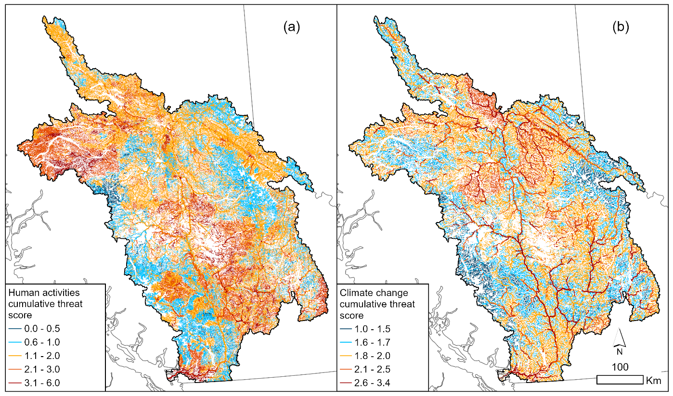
Figure 1. (a) Human activity and landscape disturbance based additive cumulative threat score, and (b) Climate change additive cumulative threat score for 2040-2060 under RCP 4.5. Blue indicates low threat levels and red indicates high threat levels.
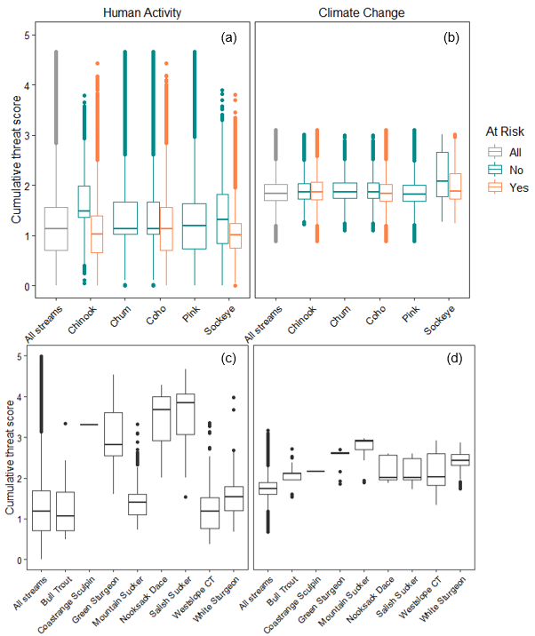
Figure 2. Tukey’s box-whiskers plots of the cumulative threat scores from human activity and landscape disturbance based threats and climate change based threats for all streams in the FRB, (a & b) accessible streams within salmon CUs, and (c & d) delineated stream habitats of fish SAR. Salmon CUs identified as Special Concern, Threatened, or Endangered by COSEWIC were distinguished from those not at risk.
Figure 3. Median cumulative threat composite scores for watershed groups in the Thompson-Nicola EDU based on the multiplicative value of human activity and landscape disturbance based cumulative threats and modeled environmental favourability for spawning (row a) Chinook, (b) Coho, (c) Pink, and (d) Sockeye Salmon. Modeled environmental favourability probabilities used in the composite score were based on projected (column a) current and (b) future conditions for all stream reaches (≥ 4th order) including inaccessible streams from dams and natural barriers. Watershed groups that are largely inaccessible are identified by hatched lines, and salmon CU boundaries in black outlines. Colour scale indicates increasing need for localized investigation and potential restoration.

📈 References
Include full references for any publications referenced in other sections. Please format references in Harvard style according to Instructions to Authors for the Canadian Journal of Fisheries and Aquatic Sciences, at Canadian Science Publishing.

Bayly, M., Tekatch, A., Rosenfeld, J., Jarvis, L. & Enders, E. 2024. Cumulative Effects Model for Prioritizing Recovery Actions (CEMPRA): User Guide. Documentation prepared by ESSA Technologies Ltd. for the BC Water, Land and Resource S. Available from: https://essatech.github.io/CEMPRA/ [accessed 29 December 2025].
DFO. 2022. Geospatial mapping tools, indicators, and metrics for fish habitat in the Pacific Region. DFO Can. Sci. Advis. Sec. Sci. Resp. 2022/047.
Halpern, B.S., and Fujita, R. 2013. Assumptions, challenges, and future directions in cumulative impact analysis. Ecosphere. 4: art131. doi:10.1890/ES13-00181.1
Halpern, B.S., McLeod, K.L., Rosenberg, A.A., and Crowder, L.B. 2008a. Managing for cumulative impacts in ecosystem-based management through ocean zoning. Ocean Coast. Manage. 51: 203–211. doi:10.1016/j.ocecoaman.2007.08.002
Iacarella, J.C. and Weller, J.D., 2023. Predicting favourable streams for anadromous salmon spawning and natal rearing under climate change. Can. J. Fish. Aquat. Sci., 81(1), pp.1-13. doi:10.1139/cjfas-2023-0096
Iacarella, J.C., Paterson, K., Potapova, A., and Weller, J.D. 2025. Geospatial Indicators and Metrics for Threats to Fish Habitat in the Fraser River Basin with Thompson-Nicola as a Case Study. DFO Can. Sci. Advis. Sec. Res. Doc. 2025/013. xiii + 126 p.
Rosenfeld, J., Gonzalez-Espinosa, P., Jarvis, L., Enders, E., Bayly, M., Paul, A., MacPherson, L., Moore, J., Sullivan, M., Ulaski, M., and Wilson, K. 2022. Stressor-response functions as a generalizable model for context dependence. Trends Ecol. Evolut. 37: 1032–1035.
doi:10.1016/j.tree.2022.09.010

